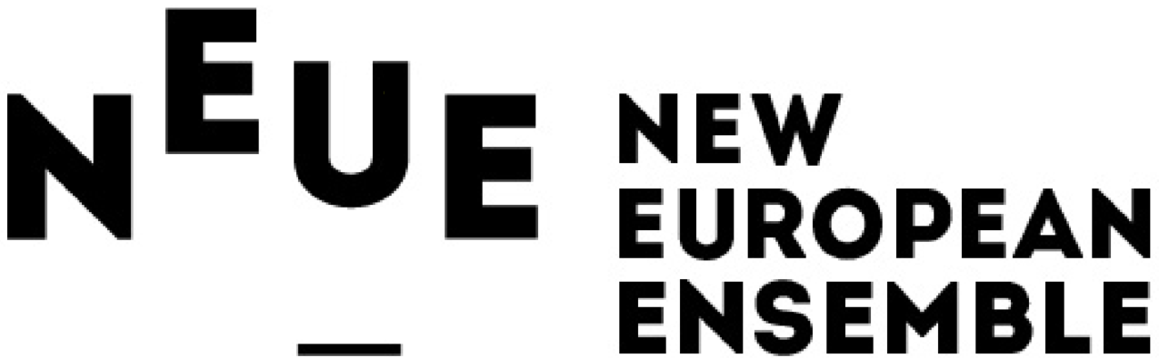

Press Release, February 26, 2021

New European Ensemble presents the film 1984 with Edward Snowden on NPO Television Network

New European Ensemble presents the premiere of the Dutch language film 1984 with Edward Snowden on Sunday March 21 at 23:05 on Netherlands NPO2 Extra. The film features actor Boris van der Ham and whistleblower Edward Snowden and is based on George Orwell’s classic novel. The Estonian composer Mihkel Kerem wrote a new ensemble piece based on the novel, which will be performed by the New European Ensemble in the film. The premiere of the English language version of the film with actor Joseph Thompson, will be on April 23 at 19:00 on OnJam.tv. A tour with performances in theatres will begin in October 2021.

1984 Movie Premiere
The New European Ensemble drafted Gijs Besseling to create a full-length movie combining Kerem’s ensemble piece with texts from Orwell’s novel acted by Boris van der Ham and Joseph Thompson and presented by Edward Snowden. Musicians from the ensemble also act in a gripping cinematic rendition of the events from the novel.

Current Affairs and 1984
Snowden revealed the extent to which the American NSA was recording the electronic communications of ordinary citizens. In Snowden’s words: “Increasingly we lose our seat at the table and our ability to steer the future and all of these processes begin from the corruption of language which was Orwell’s greatest fear.” The lengths to which governments and corporations are prepared to go to intercept and record our communications demonstrates the relevance of 1984 in our time. Today’s technology has made it possible to engage in mass surveillance and is a step in the direction of the dystopia Orwell warned us about.

New European Ensemble: new music for new audiences
The New European Ensemble aims to use this project to illustrate new music’s relevance to society. According to artistic director Emlyn Stam: “Mihkel Kerem’s illustrative piece along with our performance in 1984 give emotional weight to abstract topics like privacy, data collection and authoritarian populism. This allows the ensemble to pursue its mission to present contemporary repertoire in a compelling and accessible way to a broad audience.”

Dutch Movie premiere 1984 on NPO2 Extra
Sunday March 21 2021, on NPO 2 Extra: 23:05h

English Movie Premiere
April 23 2021, 19:00 GMT+1
OnJam https://www.onjam.tv

First tour dates 1984 in in theatres starting October 2021
Tuesday 26 October – Muziekgebouw aan ‘t IJ, Amsterdam (school performance)
Wednesday 27 October - Muziekgebouw aan ‘t IJ, Amsterdam - premiere
Thursday 28 October– Amare, Den Haag
Tuesday 2 November – Stadsgehoorzaal, Leiden
Wednesday 3 November – Spot/Schouwburg, Groningen

Trailer:
https://youtu.be/llP_fE7GaVg

Credits Film
Text: George Orwell
Film: Gijs Besseling
Director: Emlyn Stam
Assistant Director: Sophie Hunter
Actor: Boris van der Ham/Joseph Thompson
Presentation: Edward Snowden
Music and conductor: Mihkel Kerem
Cello solo: Willem Stam
Ensemble: New European Ensemble
Length: 65 minutes

Thanks to the Netherlands Performing Art Fund, The City of The Hague and the Kersjesfonds.

Note for editors: For more information contact Marjolein van Ruiten, +31 6-200 62 844, PR@marjoleinvanruiten.com

Press Kit 1984 (press photo New European Ensemble, photographer Rob Overmeer, stills from the film 1984 by New European Ensemble: Edward Snowden, Boris van der Ham, Willem Stam - New European Ensemble)
https://www.neweuropeanensemble.com/press/

EXTRA INFORMATION

Short Bio New European Ensemble
New European Ensemble (NEuE) is made up of devoted musicians from across Europe and focuses on reaching a broad array of audiences with performances of high quality new music. NEuE was founded in 2009 and is based in The Hague.
The ensemble’s mission is to present contemporary and 20th century music in an accessible and appealing fashion by combining music with film, literature, dance, theatre and visual art.

Edward Snowden’s collaboration on the film 1984
Snowden is intimately connected with the themes that run through 1984 because of his role as a whistleblower who revealed the extent to which the American National Security Agency was spying on its own citizens. A special film was made with Edward Snowden for this production. Snowden currently lives in exile in Russia and can only be reached virtually. He introduces the project by discussing the relevance of Orwell’s story to our current context. He discusses the data, phone conversations and private correspondence are collected by corporations and governments. Snowden also has a small theatrical role in the project.

